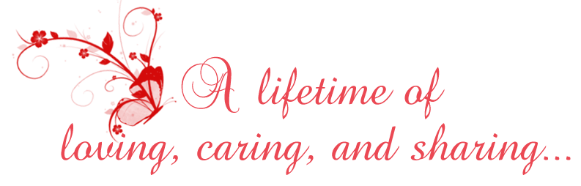
Please join us, our children and grandchildren
as we celebrate our
Golden Wedding Anniverary
on November 15, 2010
at 2:30 p.m.
Biltmore Hotel
100 Main Street
New York, New York

Kelley and Jake

