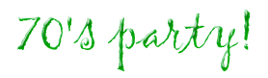
Nancy & Darren Boushell
are throwing a 70's party!

Please celebrate with us
on Saturday, October 9th
at 7:00 p.m.

Nancy and Richard Boushell’s home
899 Park Center Lane
Reno, Nevada

