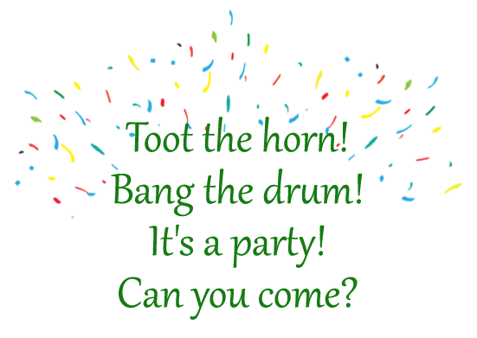
Who: Marcia Long
What: 21st Birthday Party
When: August 5th at 7 p.m.
Where: Old Street Pub, 298 47th Street

