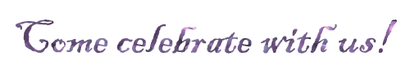
Please join us to celebrate
Billy's 21st Birthday
on Friday, March 28, 2014
at 7:00 pm
The New England Brewery
767 Montgomery Boulevard
Montgomery, IL

