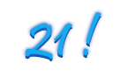
Dip in for some fun,
cocktails & fondue
to celebrate
Liz’s 21st Birthday
Friday, July 9th
10:00 p.m. to 1:00 a.m.
Dip
416 Third Avenue

