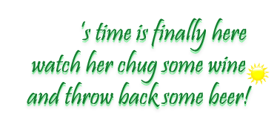
21st Birthday Bash!
honoring
Tiffany Smith
Saturday, August 31st
The fun begins at Happy Hour
Dublin Station
Delan, Iowa

Tiffany

