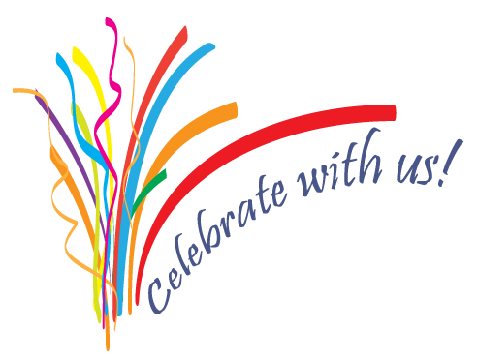
Please be my guest at
a Birthday Bash
honoring my boyfriend
Tom Madison
for his 30th Birthday
Friday, December 12
6:30 p.m.
The River Club
152 121st Avenue
New York, NY
Hosted by Jenna Callie

