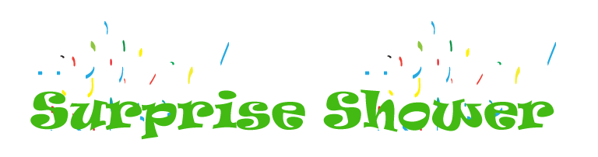
Circle will gather at Liza’s in June
Since Sonja’s baby is coming soon
Our meeting will be a
Surprise Shower

We’ll have lots of fun
before the summer’s begun
and celebrate the Holder’s
new little son!

