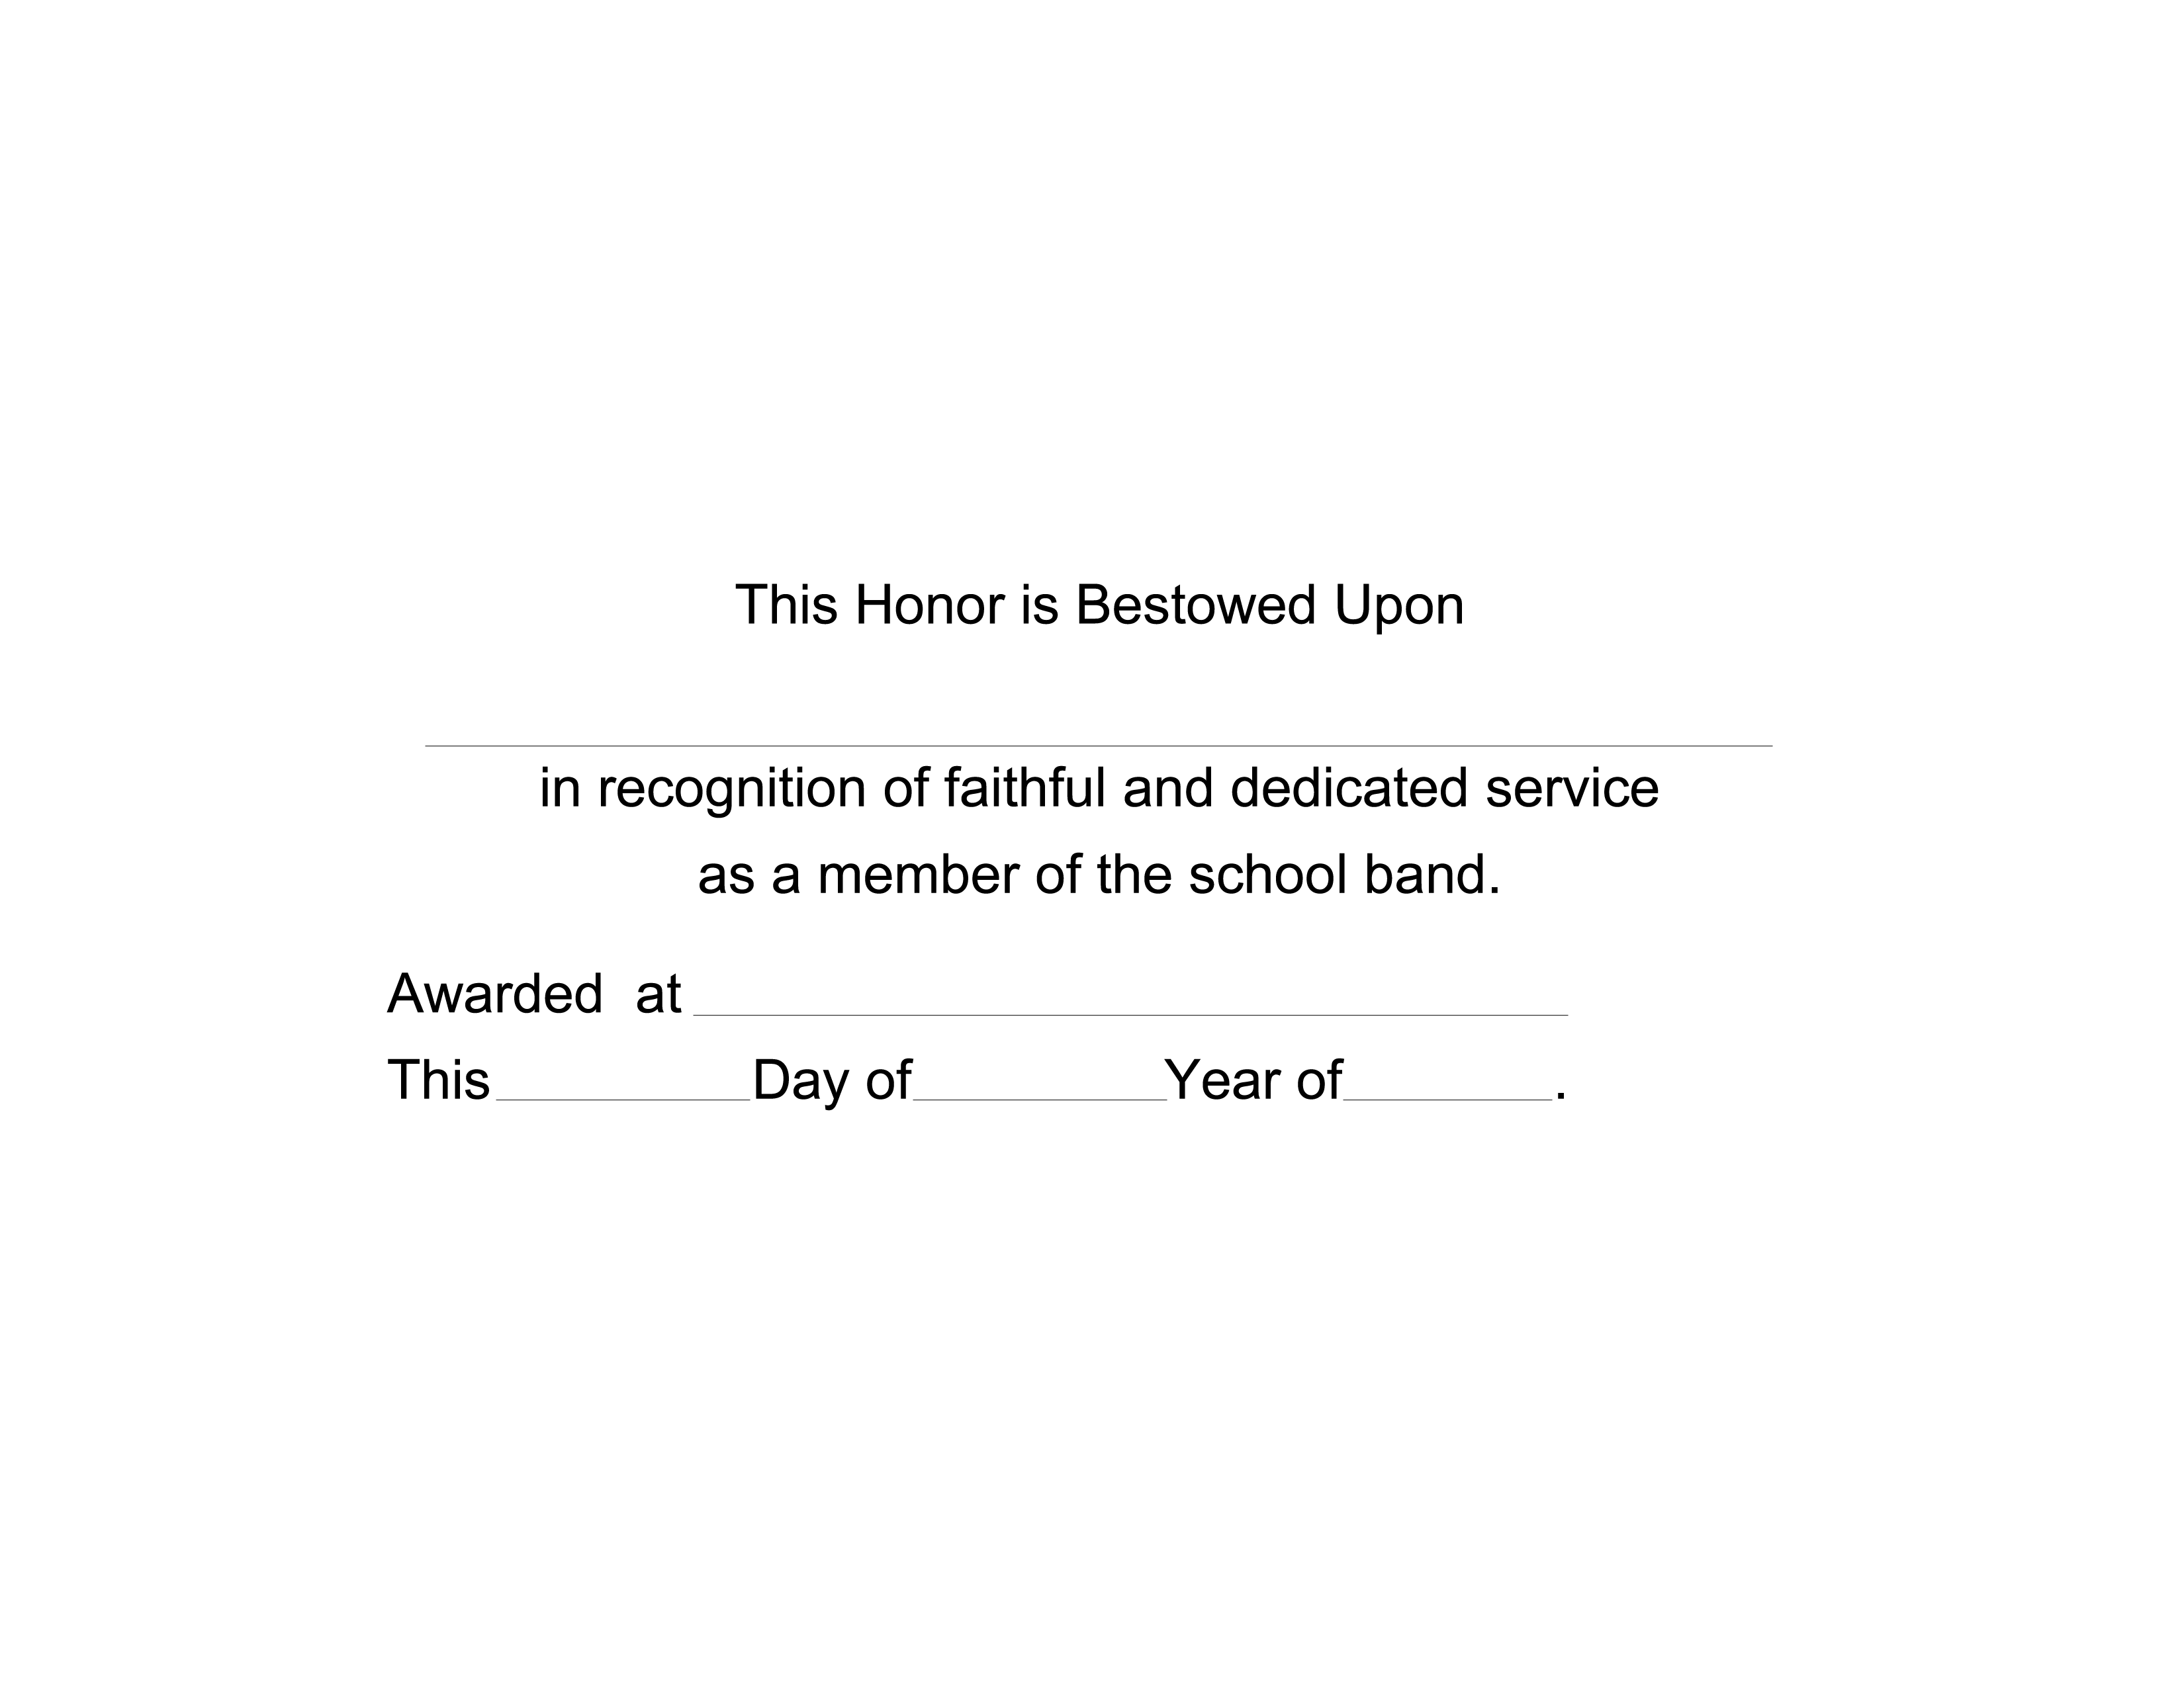

NAME HERE
SCHOOL/ EVENT
2nd
JUNE
2011

