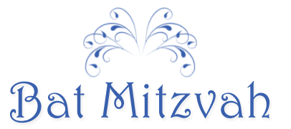
The celebration continues
immediately following services
Franklin Plaza West
86120 West Fourth Street
West Hollywood, California

