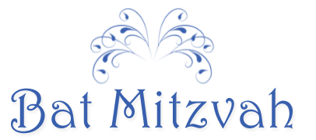
In the tradition of her ancestors
our beloved daughter
JULIA LINDSAY
will be called to the Torah
as a Bat Mitzvah
We invite you to worship with us
and share in our joy
Saturday, the eighth of September
two thousand and seven
at ten o'clock in the morning
Temple Har Shalom
Warren, New Jersey
Thomas and Paula
Cameron

