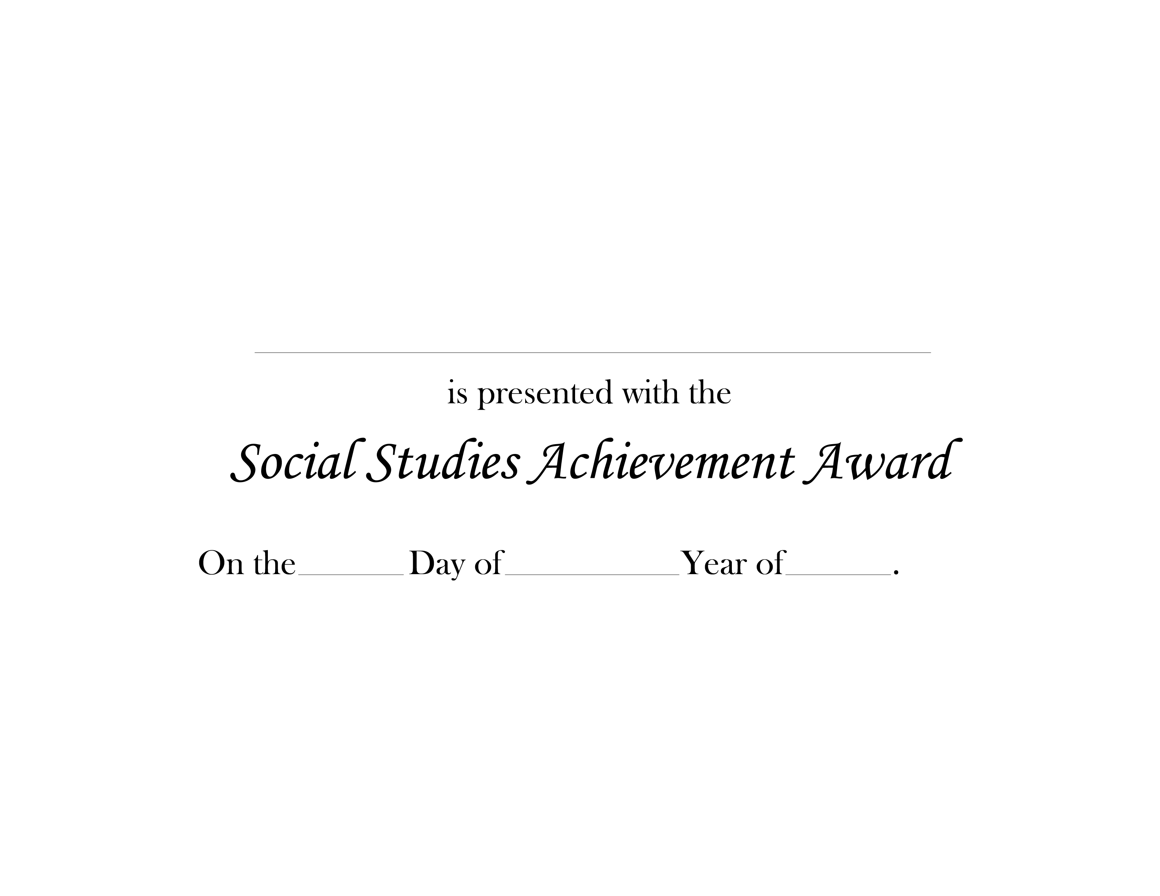
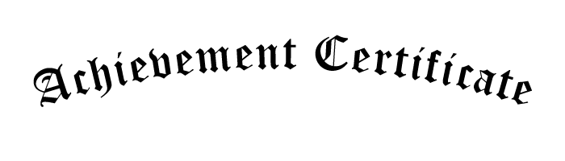
NAME HERE
2nd
JUNE
2011

