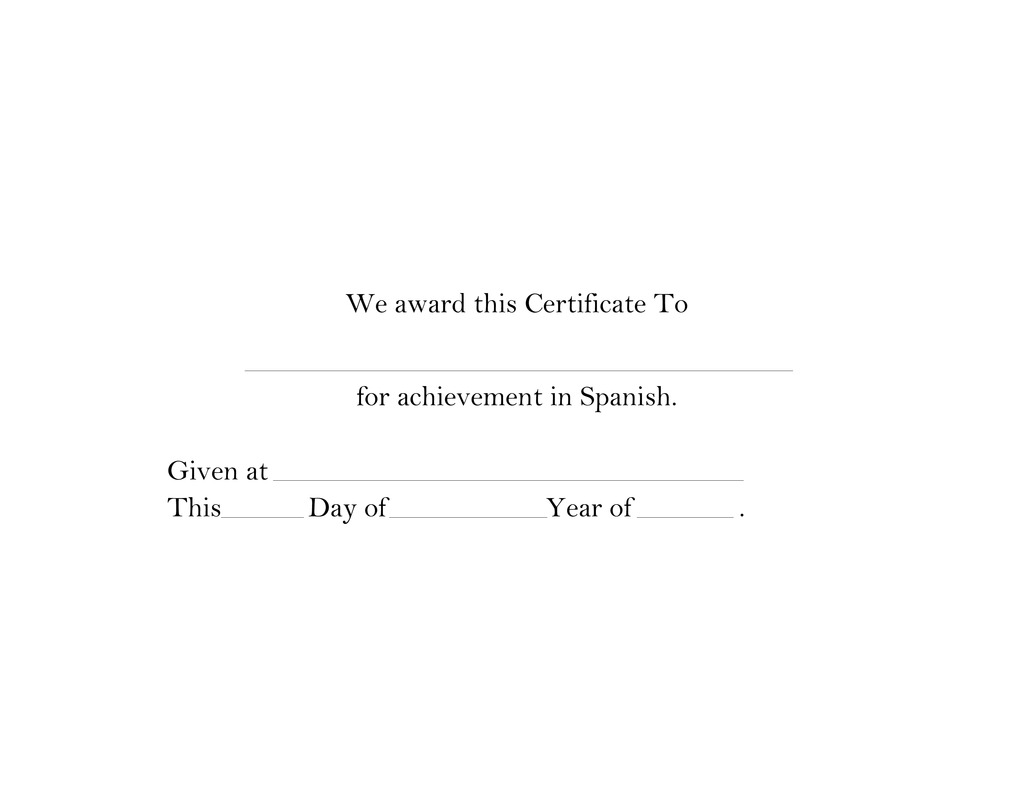
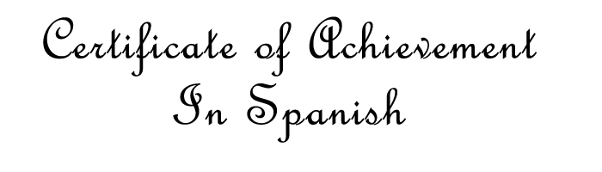
NAME HERE
SCHOOL
2nd
JUNE
2011

