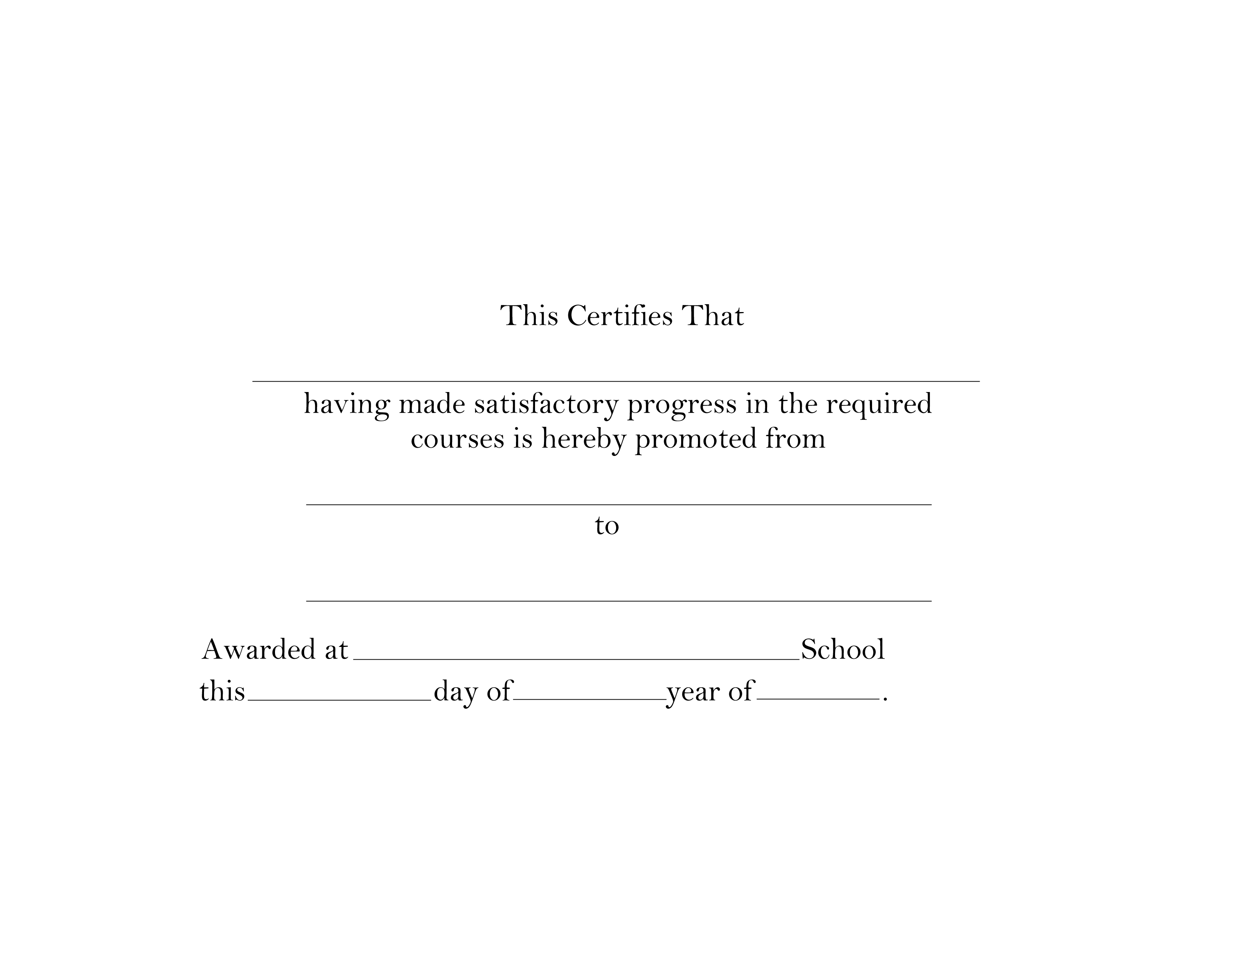


YOUR NAME HERE
POSITION/ CLASS/ GRADE HERE
POSITION/ CLASS/ GRADE HERE
PLACE
2nd
JUNE
2011

