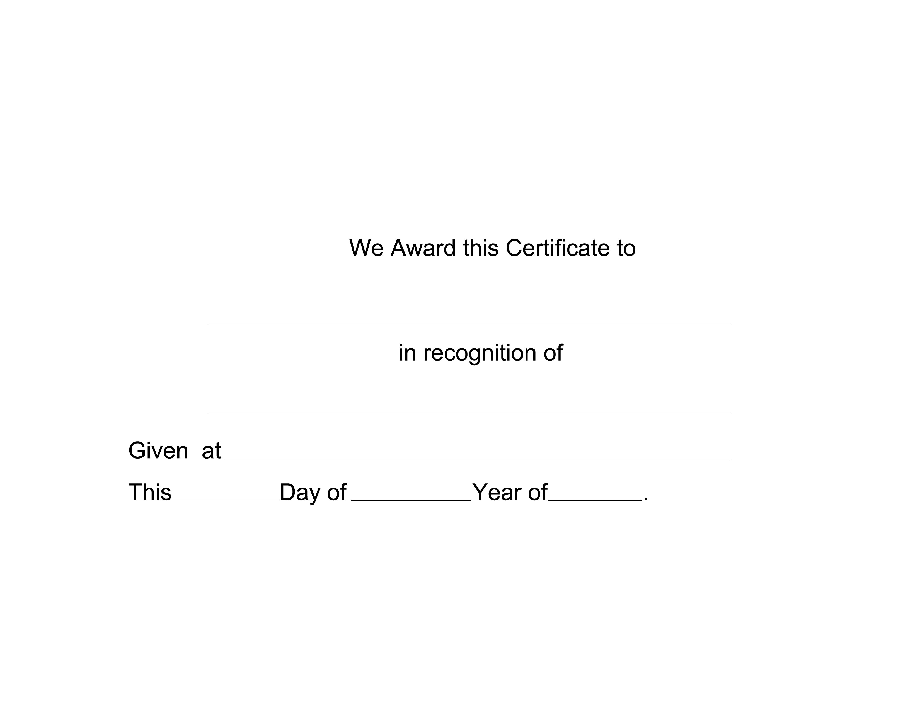

NAME HERE
RECOGNITION
SCHOOL/ EVENT
2nd
JUNE
2011

