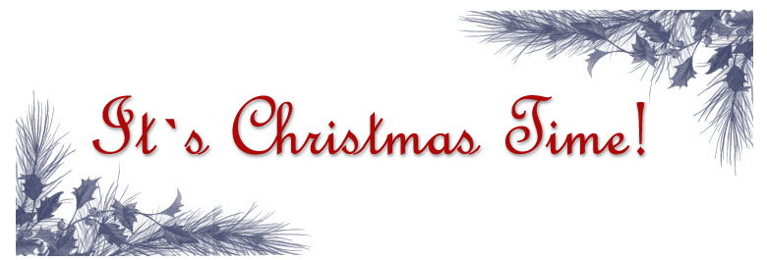
Christmas comes but once a year,
lets get together for some holiday cheer!

Cocktails and Appetizers

Saturday, December 13th
6:00 p.m. - 9:00 p.m.
995 Woodridge Road
Paterson, New Jersey

Regrets? Jingle us at (555)-595-7779

The Zerclowoski’s

