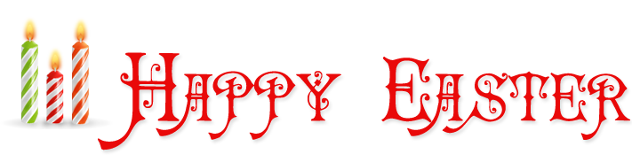
Put on your Easter Bonnet
with all the frills and
come to an Easter Party

