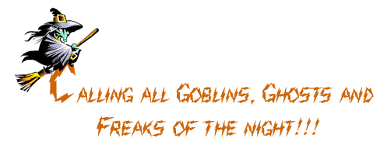
Creep, float or crawl over to our
Halloween Costume Party
on Saturday, October 31st
at 6:30 p.m.
134 Scavenger Lane
Oscar, Ohio
You'd be Ghoulish to miss this party!

MELISSA AND DAN

