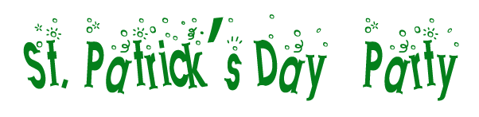
For the luck of the Irish
attend our annual
St. Patty's Day Party
on Friday, June 1st
at 7 in the evening
1235 Key Road

Hosted by your Irish friends
JACK AND LINDA
Wear your Lucky Green!

