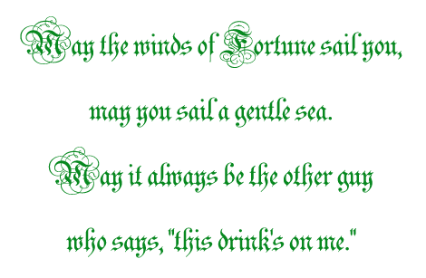
This time it's on
CM Publications
Friday, March 17, 2004 at 8:00 p.m.

The Irish Pub
245 Ireland Lane
R.S.V.P. by March 5th
231-1019

